- Open NetSuite Website, preferably sandbox
- Start ZAP HUD.
- Click "Manual Explore".
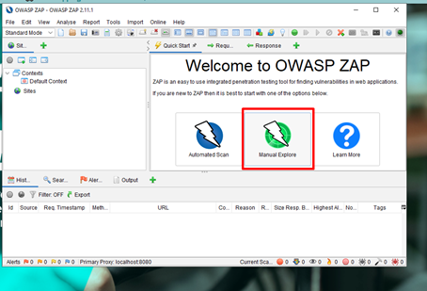
- Input URL of your client's website to secure test, then click "Launch Browser". **Watch out for 504 Gateway error.
Note: If an error occurred, same as below, this is a ZAP error when running on Windows. Please go to step-by-step troubleshoot below:
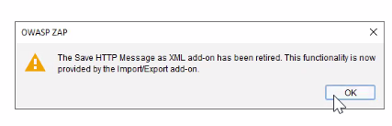
- Go to upper left part of the app and click the "Scope” button (should be grayed out with a label that says Out).
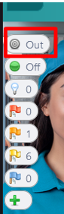

- In the Scope message that pops up, click on Add.
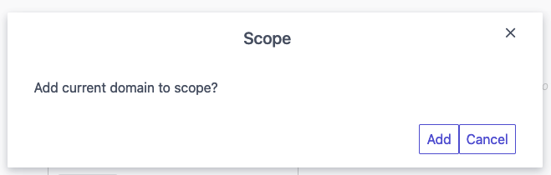

  - If adding the target is only visible after authentication, make sure do step 5 and 6 above ONLY after authenticating. Once you have added it to scope and navigated to the target location, refresh the page so ZAP adds it to the sitemap.

- Double click HUD Context in the main ZAP Window then click "2. include in Context" and click "Modify" to edit the context/limitation of the scan. And remove the wild card or "*" on the end of the URL.

  - To scan everything under the top-level domain, add the regular expression .* after the root directory.
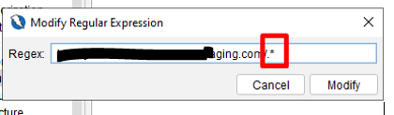
  - To restrict the scan to a specific directory or location, add the wildcard * at the end of the path you are trying to restrict to (in this case, scan is restricted to the location my_account.ssp under the scs directory).

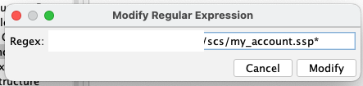

- To confirm that the Scope Exclusion Regular Expression is working, a bullseye icon should be visible for pages that are in scope as a target of ZAP.

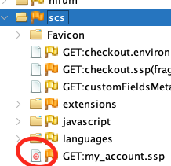

- Run the Active Scan through the main ZAP Window. Right click on HUD Context > Active Scan and wait for the scan to finish.

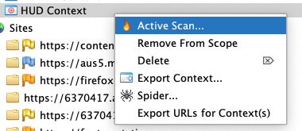

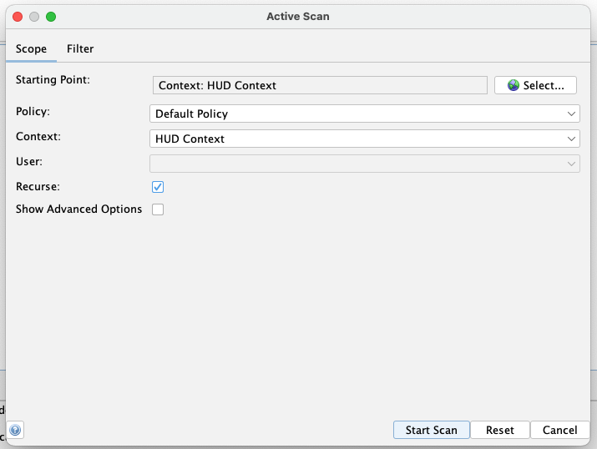

- Go to right part of the app, find the cross-hair logo then click "Attack mode". Attack mode will turn on.
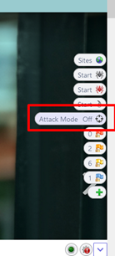
- Start the scanning by clicking "Active Scan Start" button. The button is right above the attack mode button. Wait until it is finished.
** Note: Don't close the browser so the scan process will be still active while you can work on other work. This scan may take a while. You can check the progress of the scan by hovering the mouse pointer on the active scan button**
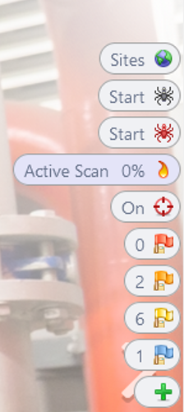
- Once done the vulnerability will show up. You can click the flags to view the findings.
- Findings consist of: High -- Medium -- Low
  - ** If critical or high came up, you should save it and report it to "Bjorn's team"**
  - **Temporary process is you should upload the vulnerability findings in Oradocs. Kerrie Ulrich(CSL) must be added**
- Complete CRM tasks, where you will mark at which time it ran and you have to add the report.
- Click "plus (+)" button to record findings/generate report.
Extract to PDF or HTML instructions:
- Export the results to a report through Report > Generate Report

- Ensure that the report will only include the results from the target scope by selecting HUD Context and the appropriate target site and click on Generate Report.
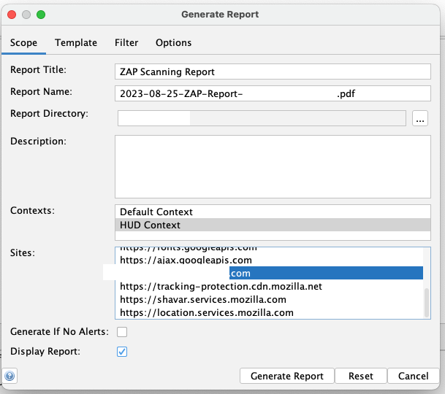

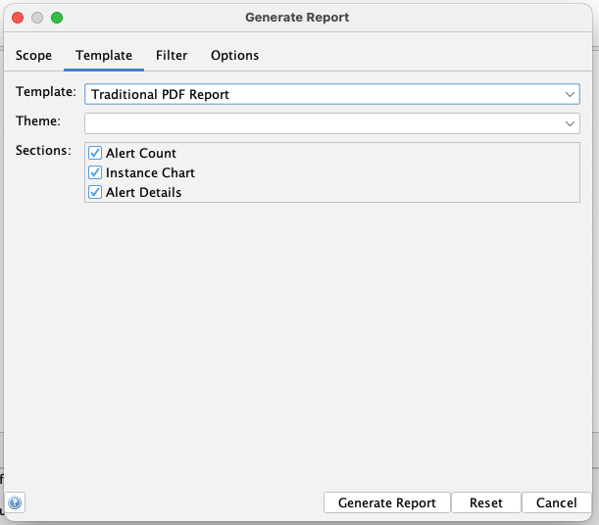

Recording of first test: Security Testing - Zap Installation
Note: Recording session is not finalized, it is being edited to only contain how to run Zap Hud.

OWASP
Troubleshooting of OWASP ZAP Windows error:
- Backup your browser preferences (bookmarks, etc.) and export it to a file that can be used later for restoration
- Close all browser instances of Firefox and Chrome; go to Task Manager (Ctrl+Shift+Esc) and terminate all running processes of chrome.exe, firefox.exe, geckodriver.exe, chromedriver.exe)
- After ensuring that no browser instance are active, uninstall OWASP ZAP completely and remove all preference file associated to it (this should be in C:\Users\<your username>\OWASP ZAP; delete this whole folder AFTER uninstalling the program through Windows Control Panel)
- Uninstall Google Chrome completely; download the latest version and reinstall Google Chrome after a machine restart – this should add Google Chrome to the PATH variable of Windows again
- Close Google Chrome and check task manager for all instances of chrome.exe and chromedriver.exe – terminate if you find any of them
- Install OWASP ZAP 2.11.1 again
- Run OWASP ZAP and install Windows WebDrivers from the updates/marketplace pop-up window
- In OWASP ZAP, navigate to Tools > Options > Selenium
- In the Selenium section, under WebDrivers, click on the Bundled button to revert the WebDrivers to the ones that ZAP installed
- The path should be C:\Users\<your username>\OWASP ZAP\webdriver\windows\32\chromedriver.exe and C:\Users\<your username>\OWASP ZAP\webdriver\windows\32\geckodriver.exe
- Run Manual Explore with HUD enabled using Chrome as the preferred browser – the recent installation should be picked up by ZAP
- See if ZAP HUD loads on the proxied instance of Google Chrome
Limiting Scan Scope:
1. Set up a manual scan with HUD enabled in OWASP ZAP as described in the previous steps (follow only up to step 4 of the first section in the document)
2. Perform authentication if necessary and navigate to the specific directory/page where the scan will be restricted
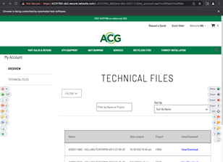
3. Click on the Add to Scope button (topmost-lefthand side) of ZAP HUD and add the scope to domain.
4. Double click on HUD Context in the Contexts Section in the main OWASP ZAP window.
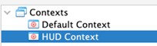
5. In the Session Properties Windows, navigate to 2: Include in Context under the 2: HUD Context section.
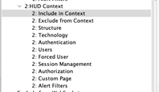
6. Highlight the default regular expression and click on Modify.
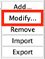
7. Change the regular expression* to one that restricts the scan to the desired directory/file; make sure that all special characters that are part of the URL are escaped with a backslash (\)
Examples:
a. Restrict to my_account.ssp and all its elements
Target URL:
https://4231760-sb2.secure.netsuite.com/c.4231760_SB2/sca-dev-2021-1-0/my_account.ssp?n=2#/technicalfiles
Regular Expression:
https\:\/\/4231760-sb2\.secure\.netsuite\.com\/c\.4231760_SB2\/sca-dev-2021-1-0\/my\_account\.ssp
b. Restrict to directory sca-dev-2021-1-0/ and all subdirectories and files
Target URL:
https://4231760-sb2.secure.netsuite.com/c.4231760_SB2/sca-dev-2021-1-0/
Regular Expression:
https\:\/\/4231760-sb2\.secure\.netsuite\.com\/c\.4231760_SB2\/sca-dev-2021-1-0\/.*
c. Restrict to directory sca-dev-2021-1-0/ only (subdirectories and contents not included)
Target URL:
https://4231760-sb2.secure.netsuite.com/c.4231760_SB2/sca-dev-2021-1-0/
Regular Expression:
https\:\/\/4231760-sb2\.secure\.netsuite\.com\/c\.4231760_SB2\/sca-dev-2021-1-0\/
* A good way to check if the regular expression has proper syntax and is pointing to the right location is through a regular expression builder like https://regex101.com/ or https://regexr.com/ .
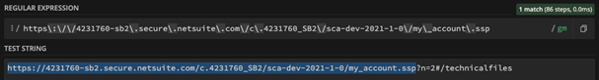
8. Save and apply changes and close the Session Properties Window.
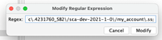
9. Right click on HUD Context in the Context Sections in the main OWASP ZAP Windows and click on Active Scan.
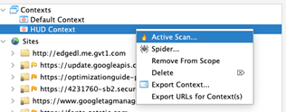
10. In the Active Scan Settings Window, keep all default values and click on Start Scan.
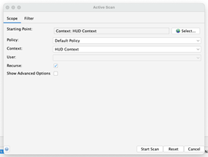
11. Wait for the scan to complete its run; any findings will be reflected in the ZAP HUD overlay running on top of the proxied browser.

